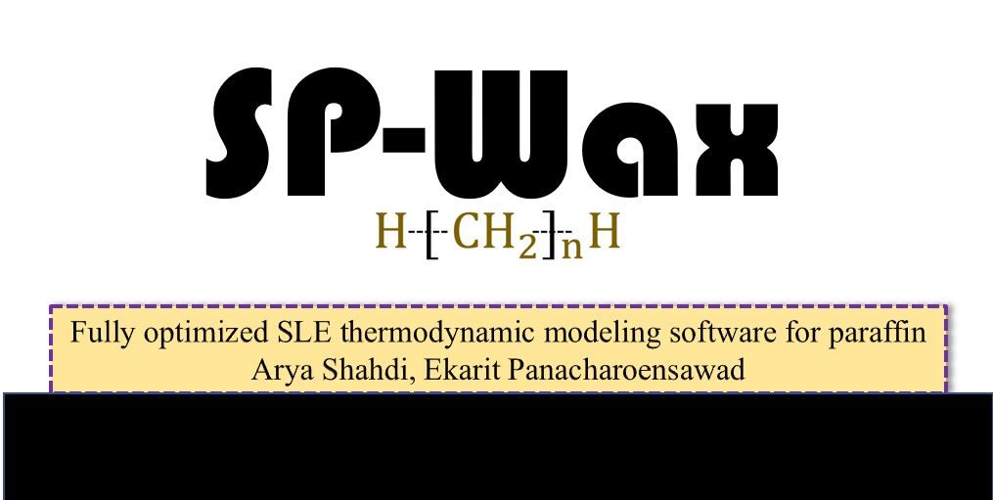

User’s Manual

Developed by:

Arya Shahdi

Ekarit Panacharoensawad

October 2018

Contents

❖ Overview 2

❖ Binary System 3

➢ Inputs 3

➢ Outputs 7

❖ Multi-component system 7

➢ Inputs 8

➢ Outputs 15

# Overview

SP-Wax is a thermodynamic software, developed by Shahdi and Panacharoensawad, which predicts various SLE characteristics of paraffinic solutions in binary and multi-component systems. Thermodynamic model is coded in C++ with a C# user-friendly interface. Such C++/C# communication is an excellent choice since it guarantees high performance and great practicality. There are four different versions of C++ source codes which are responsible for different tasks. On the other side, C# is responsible for acquiring input data from the user, calling exe-file and plotting the results. Please note that this document is a manual which enables technical and non-technical users run the software to its fullest capability. There is another manual which is provided for developers and it mainly covers theoretical framework and computation paert of SP-Wax.

The program consists of two major options including binary and multi-component systems. In binary system option, the user can predict solid solubilities n-alkane mixtures and compare the results with experimental data. On the other hand, multi-component system is an option which enables the user to approximate different SLE properties of paraffinic solutions. In multi-component system option, some of the predictions are: precipitation curve, Wax Appearance Temperature (WAT), solid and liquid phase compositions, equilibrium constant, relative concentration, Critical Carbon Number, etc. In this manual, complete instruction has been provided which guides any potential user to properly use the software.

# Binary System

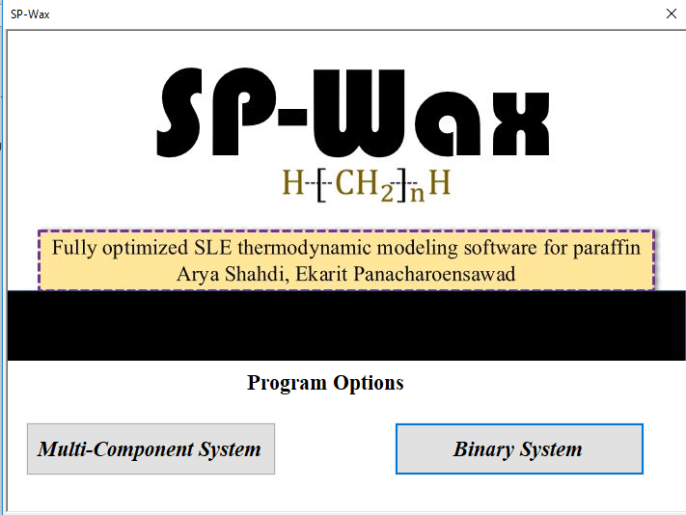

After choosing the Binary System option, user is directed to a new window as follows:

## Inputs

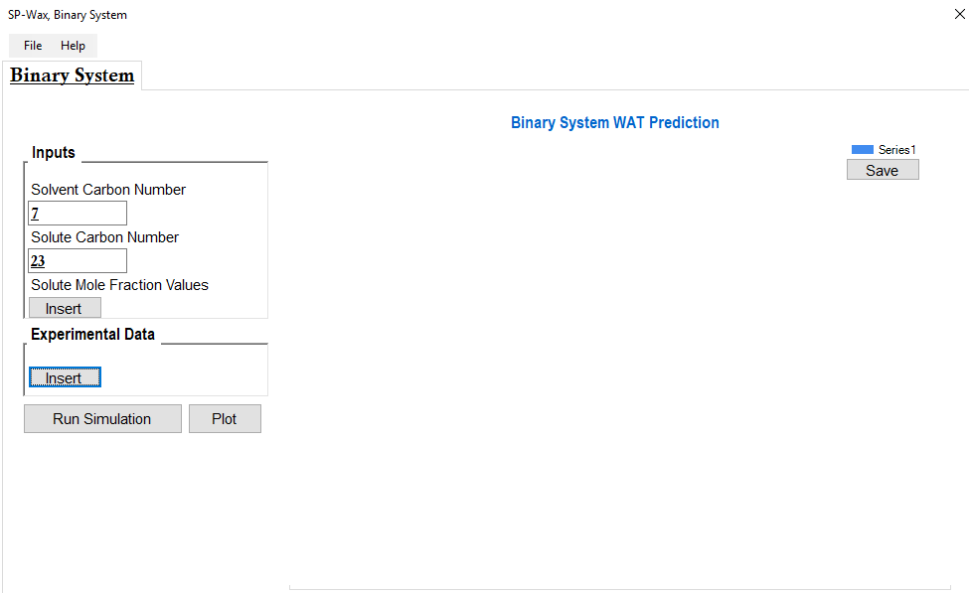

**6**

**5**

**4**

**3**

**2**

**1**

Different sections of the opened window have been numbered and are explained. Please note that binary system option is explained for binary system of $C_{7}$ and $C_{23}$. In addition, *experimental data of the same system ( $C_{7}-C_{23})$ is provided for comparison purposes.

*Provost, E.; Chevallier, V.; Bouroukba, M.; Petitjean, D.; Dirand, M. Solubility of Some n -Alkanes (C 23 , C 25 , C 26 , C 28 ) in Heptane, Methylcyclohexane, and Toluene. J.

1. In this text box, the solvent carbon number is inserted. In our example, it will be $CN_{Solvent}=7$
2. The carbon number of solute is inserted. $CN_{Solute}=23$
3. This button opens a new window that enables the user to provide solute mole fraction values.
   1. In binary n-alkane mixtures, the amount of solute could be different. When solute fraction is different, its solubility is also different. Therefore, the user should provide solute mole-fraction in the mixture. SP-Wax uses theses values and calculates the lowest temperature in which all solute molecules are dissolved in liquid phase. This temperature is similar to WAT in multi-component systems.
   2. The following window lets users insert mole fraction values of solute in the table. Then, user should click “Apply” and “OK”. By clicking “Apply”, the inserted values are exported to a text file in the same directory.

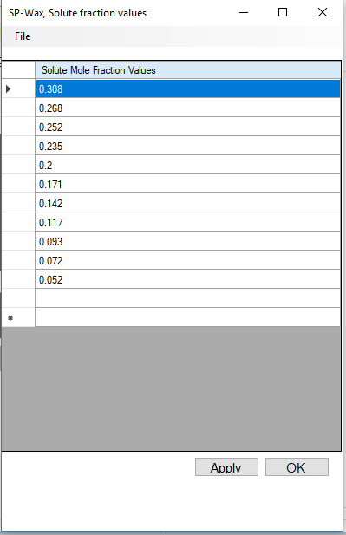

1. SP-Wax allows users to insert experimental solid solubilities against the prediction. In the following sections, experimental data are inserted:

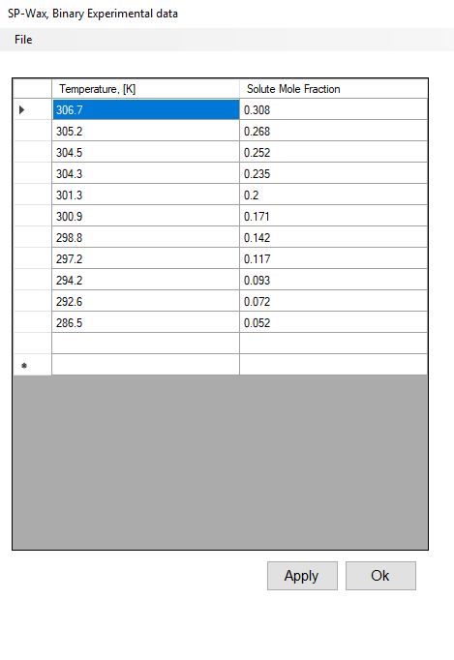

1. When “Run Simulation” button is clicked, the input data (solute and solvent carbon number values) are exported to text files. Then, the C++ exe-file of binary system (SPWaxBinary.exe) will be called and executed. The following screen appears at the time of C++ file execution. When number updating stops, user should click any key and then click “Enter” to exit from the following screen.

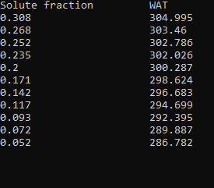

1. Simulation results and experimental data can be plotted.

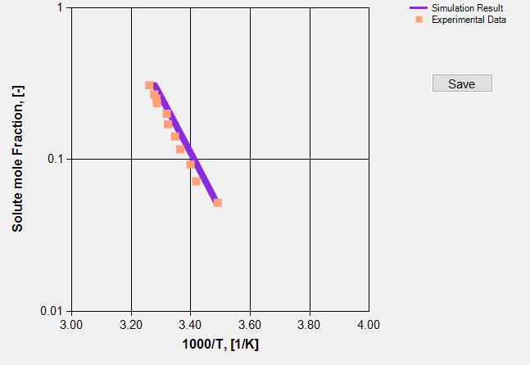

* In this example, a step-by-step instruction was given to show how to use the binary system option. For user’s convenience, all windows have open and save options (please click “File”). All input data can be saved and opened at any time.

## Outputs

* User can plot the data and save the graph. All graphs, in this software, have a “Save” button that, if it is clicked, it saves the plot in the same directory as exe-file.
* In addition, the data are also saved which can be accessed through the same directory. The text-file containing temperatures which all solute molecules are dissolved (at provided solute more fractions), is named “OutPutBinary.txt”.

# Multi-component system

To better illustrate different applications of SP-Wax, input data of a real case has been provided and it is used in different steps of this manual (*Rittirong 2014, Test# AR-21). This option of the program allows users to obtain different SLE characteristics of paraffinic solutions. One of these solutions is petroleum mixtures. Such mixtures could contain various non-paraffinic components which do not precipitate and do not react with other n-alkanes. N-alkanes, that are initially dissolved, start to precipitate as temperature decreases. In this software, different related parameters are calculated and reported. One practical example with complete input data are provided and used in this manual. Garden Banks oil case (Rittirong 2014) is the mixture which is used throughout this user’s manual. Please refer to the paper for more information and references.



*Rittirong, A. Paraffin Deposition Under Two-Phase Gas-Oil Slug Flow in Horizontal Pipes, Ph.D. Dissertation, University of Tulsa, 2014

From the first page, when “Multi-Component System” option is chosen, user is redirected to a new window. In the opened window, some input data are required to be provided. The following picture is a screenshot of the section that user needs to insert input data for multi-component system option. Different sections are numbered and explained.

## Inputs

**1**

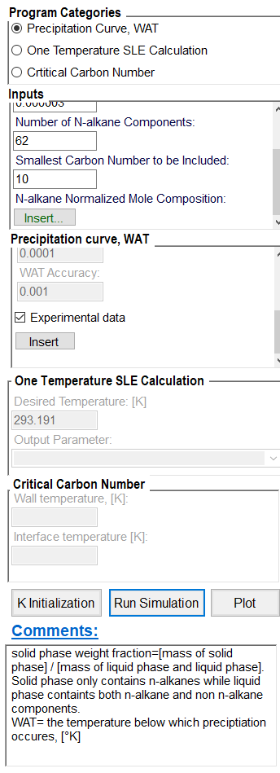

**9**

**c**

**7**

**c**

**6c**

**8**

**c**

**5**

**4**

**3**

**2**

1. “Program Categories”. User can choose one category to do a specific task. There are three tasks that can be done:
   1. “Precipitation Curve and WAT”

This option allows users to calculate the solidified weight fraction values at different temperatures (this is called precipitation curve). Second important parameter is WAT, the temperature below which precipitation occurs.

* 1. “One Temperature SLE Calculation”

When chosen, users will be able to obtain various SLE thermodynamic characteristics at any desired temperature.

* 1. “Critical Carbon Number”

This option is a supplementary output calculated from the developed model. CCN is a parameter related to aging process concept in wax deposition phenomenon in pipe.

1. “Inputs” (which are required for all categories) need to be completed by the user.
   1. “Wax Content in Total Fluid, [%]”:
      1. This program basically considers only n-alkane system from the total fluid. So, user should know the weight percentage of total n-alkane components in the mixture.
      2. In our example, the wax content of the petroleum mixture is 14.77%
   2. “Correction Factor Coefficient”
      1. Coutinho model has correction factor which is required to be adjusted to match simulation data to experimental data. There are different equations and relationships for correction factor. We have analyzed different approaches for correction factor and found that the following relation is the best one to use: $α_{ij}=1-a∙\left|ΔH_{i}^{sub}-ΔH_{j}^{sub}\right|$ Where $α_{ij}$ is the correction factor and parameter “ $a "$ is the coefficient which should be adjusted.
      2. If experimental data is available, user can adjust $"a"$ manually to match the prediction. However, there is no experimental data available we suggest the following:

We compared experimental data of four multi-component systems and adjusted $"a"$ for all of them. For three oil compositions where n-alkane system weight fraction was less than 0.15, $"a"$ was adjusted to be $3*{10}^{-6}$. However, for the case where only n-alkanes were present ($Wax Fraction=1$), very small $"a"$ (close to zero) was needed. So, we suggest using $"a"$ coefficients as follows:

$$If Wax Fraction≅1, 0≤ a<8*{10}^{-7}$$

$$If 0.15<Wax Fraction<1, 0≤ a<3*{10}^{-6}$$

$$If Wax Fraction≤0.15, a=3*{10}^{16}$$

Please note that the mentioned recommendations are based on analyzing of four multi-component systems through various parameters including precipitation curve, solid-phase composition and Critical Carbon Number (CCN). For each oil composition, all parameters were optimally predicted with one adjustment parameter (described above) at various conditions. This study is among very few ones that confirmed Coutinho et al. SLE model by analyzing different paraffin related parameters against experimental data. (not just by precipitation data points).

* + 1. In our example, the optimal coefficient is $a=3*{10}^{-6}$
  1. “Number of N-alkane Components:”
     1. Total number of n-alkane components is also required. It should be the same as the number of composition data. Number of n-alkane components are limited to 100 components. In other words, number of components should not exceed to more than 100.
     2. In our example, total number of n-alkane components are 62.
  2. “Smallest Carbon Number” which will be considered for calculations. For example, if precipitation curve needs to be calculated for high temperatures, there will be many light n-alkane components that will never contribute in precipitation. In other words, the melting point of many light components will be way below the desired temperature range that do not even play any role in calculations. In this instance, the user can exclude those light n-alkane components from the calculations without risking the accuracy of the model.
     1. For our case, the smallest carbon number is $C_{n}=10$.
  3. “N-alkane Normalized Mole Composition” should be provided too. If all n-alkanes are in liquid phase, the corresponding composition of n-alkanes ($mole/mole$) will be “N-alkane Normalized Molar Composition” which is needed in, nearly, all calculations. In addition, the summation of all compositions should be 1.0
     1. There is button “Insert” that when it is clicked, user is redirected to a new window where composition data can be inserted.

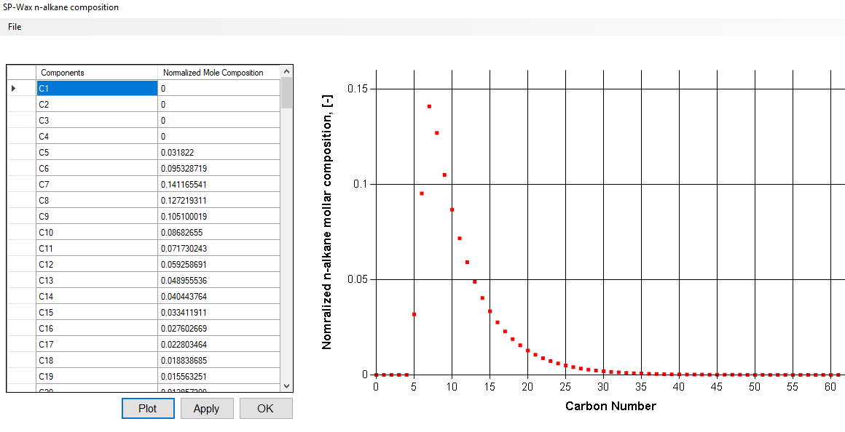

In this new window, there is a table that composition data can be inserted. The first column is for carbon numbers which will be filled up automatically and the second column is where composition data will be inserted by user. The data should be mole-composition and they should add up to unity (normalized).

* + 1. After inserting the composition data, user can plot the data.
    2. When user click “Apply” and “Ok”, the data will be exported to text file and the window will be closed.
    3. In addition, by clicking “File” (top-left), user can save and upload files from desired directory.
    4. Composition data of our case is provided as a part of supporting documents under “GardenBanksCompo.bin”

1. In section “Precipitation curve, WAT”, user provides some more information, specifically, for generating precipitation curve. The required parameters are listed below:
   1. Precipitation curve is plotted from several solid phase weight fractions at different temperatures. solid phase weight fraction = [mass of solid phase] / [mass of liquid phase and liquid phase]. Solid phase only contains n-alkanes while liquid phase contains both n-alkane and non n-alkane components.
   2. “Number of Data Temperature Points” is the number of data points in precipitation curve. If number of data results in temperature range above WAT, the software will stop at WAT.
   3. “Starting Temperature: [°K]” is the lowest temperature from which precipitation curve is plotted.
   4. “Temperature Step: [°C]” is the temperature interval between two consecutive temperature data points. The value for this parameter is chosen to be 0.5 $°$ C and user cannot change it. However, user can change this value from C# code to whatever desired value.
      1. Since temperature step is chosen to be 0.5 $°$ C, user can start from a temperature and move till the desired temperature is reached. However, if user wants to reach WAT, large number of temperatures should be inserted (that potentially passes WAT). The program will stop the calculations when WAT is reached so, it is not important if the chosen number of temperatures are too large.
   5. The next two parameters are accuracy limits meaning that they tell how much accuracy are set. These two values, are, also, frozen and cannot change. However, user can go to C# code and change those values as desired.
   6. Last option is to include experimental precipitation data. If experimental data are available, user should check the check-box.
      1. There is an insert button. When it is clicked, a new window opens up which allows users to insert experimental data.

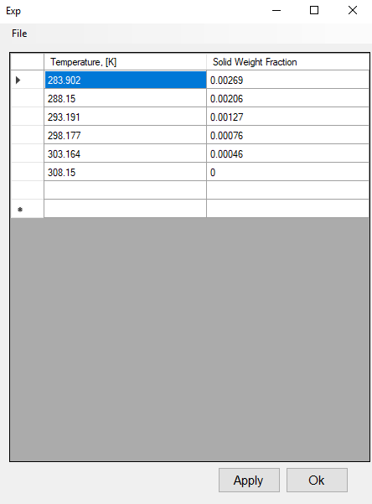

1. One temperature SLE calculation case is when one value for temperature is given and various SLE characteristics (at that temperature) are calculated. This section is only activated when user chooses “One Temperature SLE Calculation” among program categories. In this section, desired temperature will be provided by user. In addition, user can choose the desired output parameter from the combo-box to be plotted. List of output parameters which can be plotted are introduced here. Please note that all output parameters are going to be calculated and reported in text files too.

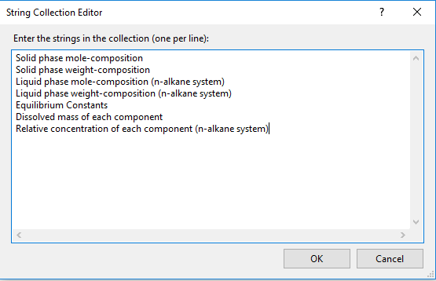

All of the output parameters are going to be explained, in detail, later in this manual.

1. “Critical Carbon Number, (CCN)” is another parameter which is calculated and reported by our software. CCN is a thermodynamic property which is expected to be calculated by a reliable thermodynamic model. Please note that the concept of CCN is important in wax deposition phenomenon under dynamic condition in pipe. User is advised to refer to the paper for more complete explanation about this parameter. Please note that this software is the first program that verifies the again process using purely SLE thermodynamic model and reports CCN.
2. “K Initialization”. This button should be clicked before “Run Simulation” and “Plot” otherwise, there is a chance that program does not run. In SLE modeling, equilibrium constants can vary from ${10}^{-4} to {10}^{7}$ for different carbon number components at one temperature. In SP-Wax initial values of K are required for C++ source file to run. Incorrect initial values of K can result in convergence problem and it can stop the program. That is why we have come up with a solution where sets of initial values for equilibrium constants will be calculated to avoid any convergence problem.
3. When “Run Simulation” button is clicked, all input data will be exported to text files. The generated text files will then be accessed by C++ executable files and they will run. So, based on the chosen program category, correct exe-file will be called. Three corresponding exe files are:

SPWaxPrecipitation.exe

SPWaxOneTemperatureCase.exe

SPWaxCCN.exe

1. By clicking this button, desired parameters are plotted at assigned locations.
2. This section is devoted to explanatory comments of different functionalities and parameters.

## Outputs

Different outputs are expected based on chosen program category.

1. Precipitation curve and WAT
   1. After inserting the required inputs, user should click on “K Initialization” and then “Run Simulation”. When clicked, C++ exe-file is called, and such screen is going to open (at the of simulation run).

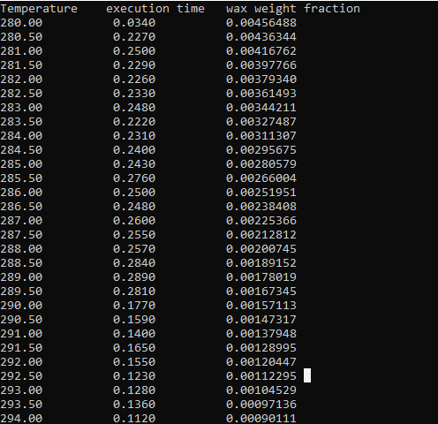

* 1. Then data can be plotted. The following picture is the resulted precipitation curve for our case.

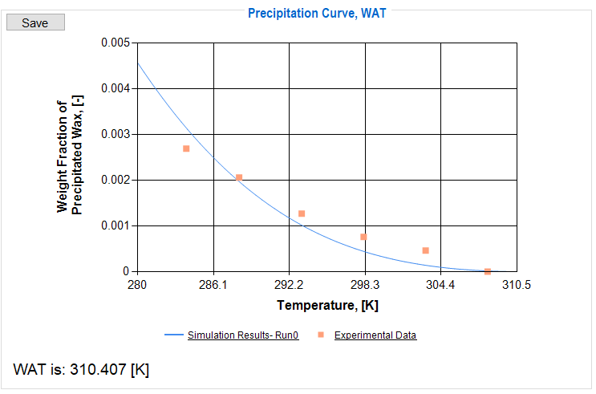

Please note that different inputs can be inserted and plotted on the same graph. This helps the user to perform sensitivity analysis of different parameters

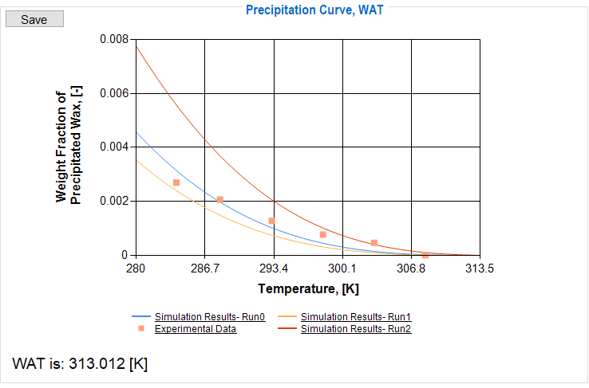

Reported WAT is also reported

* + 1. Please note that graph can be saved by “Save” button in the same directory.
    2. To get the actual digital data, they are saved as “Wax weight fraction.txt”. The text file is generated in the same directory as the exe-file.
  1. To calculate each point of precipitation curve, many SLE properties are, also, calculated. For example, equilibrium constant values, solid and liquid phase compositions need to be updated correctly to find the right value for precipitation. Therefore, composition data of solid phase at all temperatures are also reported which could be accessed by a trackbar. These compositions are only for precipitated phase and all components are n-alkanes. User can use the trackbar to plot the weight composition of solid phase at different temperatures. User can access all composition data through a text file named as “SolidWComposition.txt”.

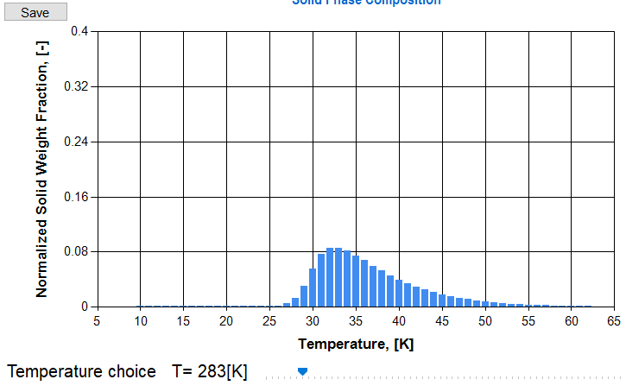

Track bar

As mentioned, user can change the trackbar to access solid phase composition at desired temperature

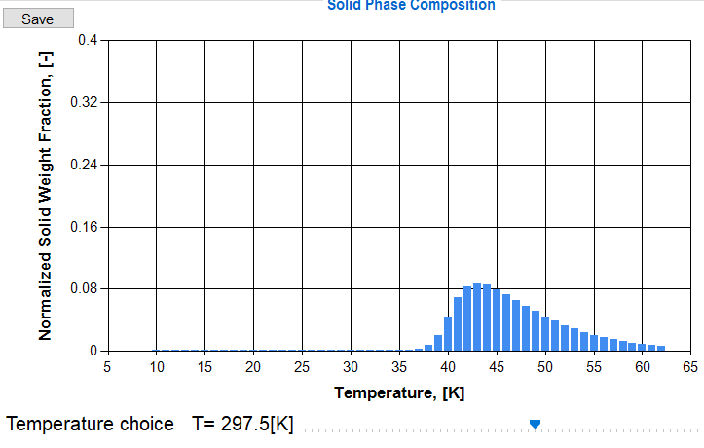

1. “One temperature case”
   1. In one temperature case, software calculates various SLE characteristics of paraffinic solutions at one specific temperature. After running the simulation, user should choose one output parameter from the combo-box for plotting. The outputs are:
      1. “Solid phase mole-composition” (Y-axis (each bar) =[mole of ith n-alkane in solid phase] / [total mole of n-alkanes in solid phase]). This is an important parameter which is predicted and reported. In addition, the data are also generated and stored in the same directory as exe-file as “SolidMolarComposition.txt”. Here is an example of solid phase composition text file.

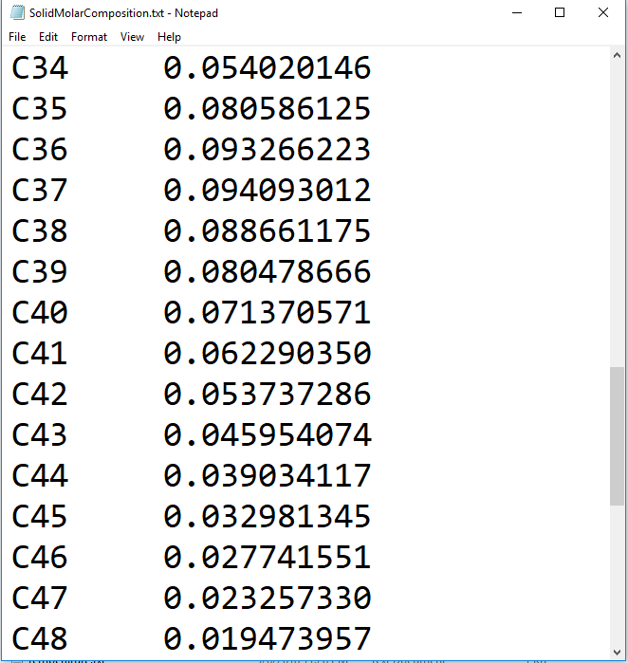

* 1. “Solid phase weight-composition” (Y-axis (each bar) =[weight of ith n-alkane in solid phase] / [total weight of n-alkanes in solid phase]). The parameter is similar to the previous parameter however, composition is reported as weight composition. The name of the text file is “SolidWCompositionOnetemp.txt”

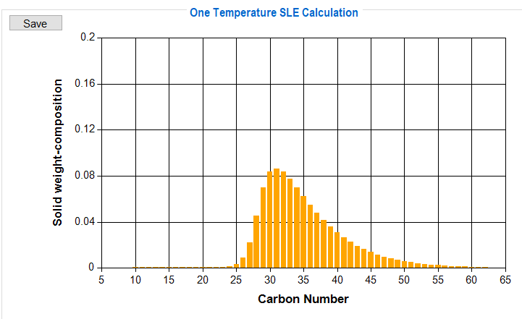

* 1. “Liquid phase mole composition (n-alkane system)” (Y-axis (each bar) =[mole of ith n-alkane in + liquid phase] / [total mole of n-alkanes in liquid phase]). For this parameter, composition of dissolved n-alkanes will be reported. Please note that these compositions are specific to n-alkane system (not the whole liquid sample). The output file’s name is “LiquidMolarComposition.txt”.

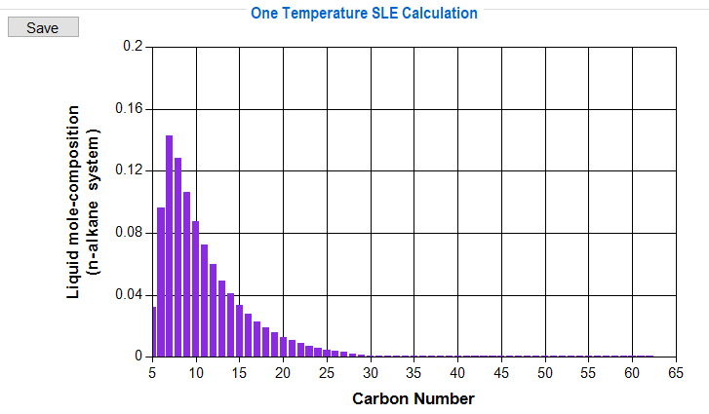

* 1. “Liquid phase weight composition (n-alkane system)” (Y-axis (each bar) =[weight of ith n-alkane in liquid phase] / [total weight of n-alkanes in liquid phase]). This parameter is similar to the previous output however, it is in weight composition. The text file is generated by the name of “LiquidWComposition.txt”.
  2. “Equilibrium constants”. Equilibrium constants are important, and they are saved as text file named “K_values.txt”.

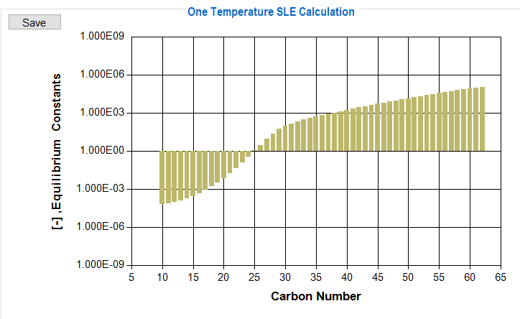

* 1. “Dissolved mass of each component” (Y-axis= dissolved mass of ith n-alkane in liquid phase based on the assumption that the total mass of the system [paraffin and non-paraffinic components in liquid and in solid phases] is equal to 1 kg). As previously mentioned, the user should provide the wax content of the mixture. If we assume that the fluid sample (paraffinic and non-paraffinic components) is 1kg then wax components (in liquid and in solid phase) should be $WF$ kg which is known. The following graph shows the mass of each n-alkane component in liquid phase if 1kg of total fluid mixture is assumed. This parameter is used in Relative Concentration calculation.

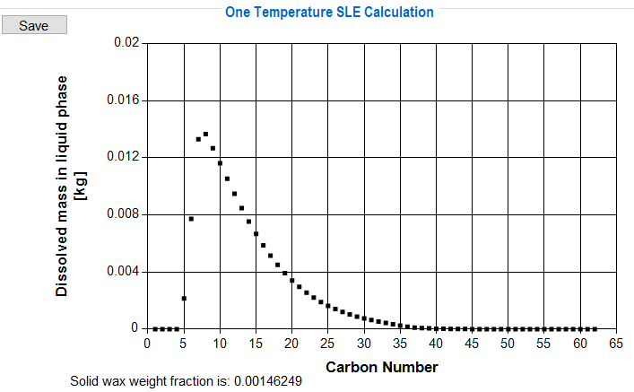

* 1. “Relative concentration of each component” ([mass of ith n-alkane that is dissolved in liquid phase] / [volume of n-alkanes in liquid phase]). This parameter is defined to verify the aging process in wax deposition phenomenon (please refer to paper and developer’s manual). If we only consider n-alkane system, concentration of each carbon number (within n-alkane system) is called Relative Concentration. The output data are stored as “RelativeConcentraion.txt”

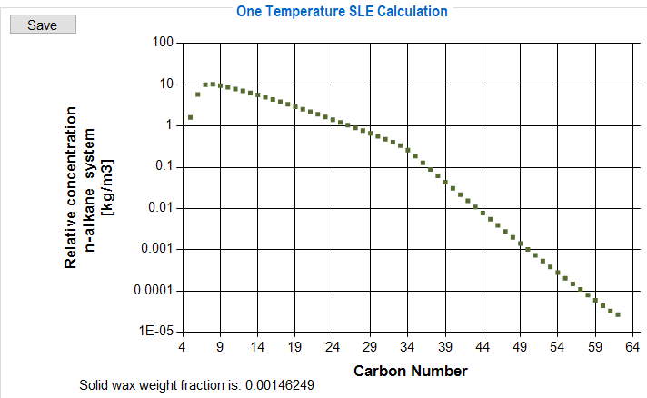

1. “Critical Carbon Number” of CCN is a thermodynamic property which is used to explain the aging process in wax deposition phenomenon in dynamic condition. By using the developed software, we were able to approximate CCN accurately by just having deposit’s interface and wall temperatures. For our example, in case 1, $T_{inteface}=291.16 °K$ and $T_{wall}=289.95°K$. The resulting relative concentration gradient plot is as follows. The smallest carbon number with positive relative concentration gradient value is called CCN.

